Drone Policy
Purpose of report
For discussion.

Summary
Unmanned aerial vehicles or drones have rapidly developed over the past two decades. As they have become cheaper and smaller their potential commercial applications have increased.
Drones could become an increasingly common sight in our sky’s in the years ahead and as their use becomes increasingly common local authorities will need to take a view on what uses are acceptable and in what circumstances. This paper examines potential public sector and commercial uses for drones, their public acceptability and early regulatory and infrastructure issues that will need to be addressed.
Kathy Nothstine, The Lead for Future Cities at NESTA will present to the board on their ‘Flying High’ project which is working with councils on the impact of drone deployment.

Recommendations
Members are asked to consider the future role of the Board in supporting councils to make the best use of this new technology and in establishing a policy position on the role on councils, if any, in regulating the use of drones.
Action
As directed by members

Contact officer: Andrew Jones
Position: Policy Adviser
Phone no: 0207 764 3178
Email: andrew.jones@local.gov.uk

Drone Policy
Background
- Members have identified a desire for the board to consider our approach to drones and whether the LGA needs to take policy positions in respect to their regulation and deployment.

- NESTA have also been working on this area with a number of UK councils. They produced their ‘Flying high’ publication which is the result of their early engagement with companies involved in the deployment of the technology and public bodies interested in utilising it. They outline a number of possible use cases for drone technology. Whilst outlining the possible uses they identify that the barriers to adoption will be different depending on how drones will be used. An executive summary of the report can be found here.

- The next phase of their project is to establish a challenge prize fund to design a series of innovation challenges and develop test beds to pioneer safe, sustainable drone systems that deliver the benefits for cities and citizens outlined in their potential use cases.

- The NESTA approach identifies three distinct phases which are useful when thinking about how public bodies should respond to the development of potentially disruptive technology:

  - Identifying the socially acceptable uses for drones

  - Understand what regulatory framework this would need

  - Understanding what kind of infrastructure would be needed to facilitate roll out
Issues
- It is crucial that we understand how this technology is proposed to be used. Different calculations about the extent to which we introduce new regulation and infrastructure at public expense will be necessary depending on the use case. The acceptable amount of resource and disruption will almost certainly be different depending on whether the technology is being used for commuting above traffic to deliver take away food quicker or for example delivering emergency medicines quickly to remote locations.

- NESTA’s research identifies a number of more socially acceptable deployment opportunities. For example utilising drones for emergency responses, accessing otherwise remote communities and locations and reducing the expense of routine public body activities like asset inspection and traffic monitoring.

- Once it is established how it is proposed the technology will be initially deployed this will inform the extent to which there is a need for regulatory and infrastructure development.

- There has been recent press coverage of councils using drones for planning enforcement. Whilst offering efficiencies for monitoring planning compliance there will be a public debate about the privacy implications of public authorities using drones in this way. Coverage of the issue is available here.

- The DFT has conducted polling on the public’s view on drone use and concerns members of the public have about them. The polling which was conducted in June 2018 found that by far the biggest concern people had was privacy issues.
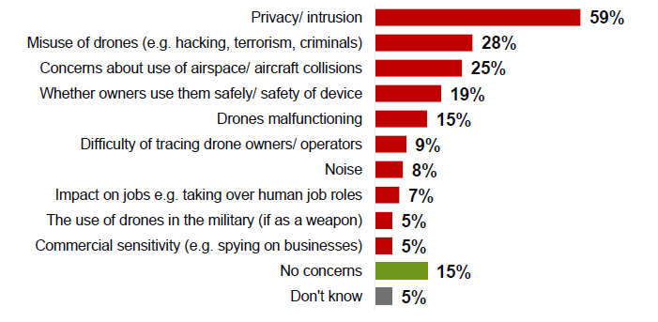
- DfT also asked what uses people believed they would hypothetically support. They generally supported public sector uses much more strongly than commercial ones.
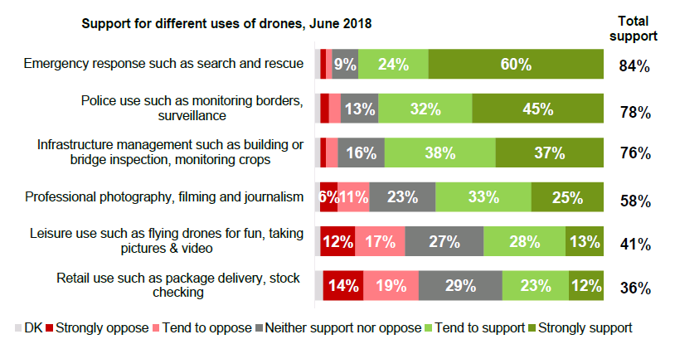
Regulatory Framework
- As part of their future of urban mobility programme of work the Government has launched a regulatory review of drones and future flight. They initially reported their findings in January. Their initial proposals are confined to how drones fit into the remit of existing aviation legislation.

- If proposals for future uses are developed which involve either flight out of sight of the drone operator and/or routinely using air space below 400 feet using existing aircraft regulation will not be adequate.

- If drones intend to operate routinely below 400 feet there will need to be serious discussion of who regulates low level air space and how we will decide who is entitled to use this public resource. The LGA currently has no developed policies on whether councils wish to be involved in the regulation of low level air space whether for public sector or private uses.

- As part of their deployment, public bodies will need to consider what current regulation prevents publicly beneficial drone uses and also what new regulatory frameworks will be needed to enable sustained drone use.
Infrastructure needs
- If and when commercial drone use becomes widespread there will be a need to accommodate it with landing and other types of infrastructure. There will also be a need for spatial design policies that accommodate low level flying alongside other methods of transport and delivery.

- There will also need to be institutional infrastructure. If there’s an intention to regulate low level air space there needs to be the capacity to enforce any restrictions that are in place. Local authorities would need considerable new expertise if they were to take on this role.
Aviation 2050 The future of UK aviation Green Paper
- There is an ongoing Government consultation on a green paper about the future of aviation. The consultation recognises that drone operation is a completely new model of flying and will need a new type of regulation, although it is not clear how that framework will work. If drone flight is to become widespread it is highly likely it will need its own regulatory framework in addition to traditional aviation regulation.

Future of urban/rural mobility
- The Government has launched a future of urban mobility strategy and next year it is scheduled to launch a future of rural mobility strategy. The strategy can be accessed here. The strategy feeds into the grand challenge of the industrial strategy and highlights the government’s actions in this area.
NESTA flying high programme
- Run by the Challenge Prize Centre at Nesta, in partnership with Innovate UK, Flying High is the first programme of its kind to convene city leaders, regulators, public services, businesses and industry around the future of drones in cities.

- The first phase comprised a nine-month research and engagement process, working with five city-regions across the UK (Bradford, London, Preston, Southampton and the West Midland) to develop visions for the future of drones and assess technical feasibility and economic and social impact of urban drone applications. The outputs of this phase, which also included mapping the UK drone industry and exploring the systemic requirements for integrating drones in cities, are summarised in the Flying High Report.

- The planned next phase of the programme will be to design a series of innovation challenges and develop test beds to pioneer safe, sustainable drone systems that deliver the benefits for cities and citizens outlined in the first phase.

- The Challenge objectives include:

  - Shape city plans on the future of drones in UK cities, exploring specific applications of drones within cities and hazardous environments.

  - Identify and address key complexities such as technology, infrastructure, law, regulations, safety and privacy.

  - Detail technical and economic plans that unlock market opportunity through regulatory testbeds, open innovation technology challenges and live, real-world demonstrations.
Kathy Nothstine NESTA- Speaker Biography
- Kathy is the Lead for Future Cities in the Challenge Prize Centre working on the future of urban transport and global cities.

- Previously, Kathy served as Program Director for economic development, resilience and transport at the National Association of Counties, where she convened leadership networks of local government officials with national, philanthropic, civic and business leaders to drive innovation in local and regional economic growth, with a focus on identifying and scaling up transformative new approaches to creating stronger communities and economies based on local assets and place-based strategies.

- She has designed and delivered peer learning and capacity-building networks and training and technical assistance programmes on a variety of topics related to planning, land use, economic development, transport, infrastructure and sustainability in both urban and rural places. She has also worked in the private sector on planning, design and real estate development projects.

- Kathy holds a Master of City Planning degree from the University of Pennsylvania and a political science degree from Villanova University.
Implications for Wales
- Aviation regulation is a reserved matter. Officers are liaising on WLGA colleagues for Welsh views on future regulation.

- If proposals for new frameworks are brought forward we will examine implications for devolved authorities and work with the WLGA accordingly.
Financial Implications
- None
Next steps
- Members are asked to consider the future role of the Board in supporting councils to make the best use of this new technology and in establishing a policy position on the role on councils, if any, in regulating the use of drones. Officers will continue to monitor future regulatory developments and alert members to developments in this area.

https://assets.publishing.service.gov.uk/government/uploads/system/uploads/attachment_data/file/752240/transport-and-transport-technology-public-attitudes-tracker-wave-1-and-2-report.pdf

